Methodology

Foreign Investment Survey 2016

Table of Contents
1: General Background of the Survey | 3-4
2: Comprehensiveness of the Survey | 4
3: Stages of the survey | 5-9
4: Survey Key Documents | 10
5: Survey Staff | 10-13
Main Definitions | 14-16

1: General Background of the Survey
1.1 Introduction
Since its establishment, Dubai Statistics Center (DSC) is keen to provide the necessary statistical, social, economic and demographic data for decision makers, policy makers and those who are interested in various forms of studies. DSC strives to keep pace with the rapid and continuous development in the field of studies through developing its technical and technological capabilities to achieve a high level in its field to compete with the statistical agencies in many developed countries.
Foreign investment is one of the vital topics in which countries are interested because of its important role in the economic development process and economy income resources diversification in different fields. Foreign investments increase production capacity and raise economic growth rates. Foreign investments play a role in the transfer of the latest technology, methods of knowledge, creating more job opportunities, and achieving integration among the economic sectors which help achieving sustainable development.
Given the importance of foreign investment in economic development, DSC was keen to conduct foreign investment surveys for economic establishments which have foreign investments according to the approved international standard. This survey comes within the framework of creating an updated, accurate, and comprehensive database to assist policy makers and decision makers in identifying the position of foreign investment in the Emirate of Dubai. In addition to that foreign investment survey carried out in coordination between statistical centers in the UAE to get to the data on foreign investment at the state level without duplication, therefore we set a conditions to control and achieve the goal.
1.2 Survey Goals
The main goals of the survey are to provide data reflecting on the position of the foreign investment in Dubai- based on institutions and their distribution by economic activity and by countries from which such investment is flowed. The Foreign Investment survey is the milestone in the international investment position preparation, in addition to the fact that the survey is a main source of the financial account data in the balance of payments.
Generally, the foreign investment survey aims to:
- Providing UAE decision makers with updated and accurate data about the size of foreign investment in the country.
- Determining the size of foreign investment in the Emirate of Dubai.
- Identifying the economic sectors and activities which received the foreign investment.
- Identifying the countries of foreign investment.
2: Comprehensiveness of the Survey
All establishments with foreign direct investment (FDI) and establishments with portfolio investments listed in Dubai Financial Market, in addition to the establishments with other investments having overseas transactions in the form of loans, investments, or others, were identified based on the most recent statistical. Establishments were comprehensively identified and the study included those licensed by Department of Economic Development as well as those licensed by the Free Zones.
3: Stages of the survey
The stages of the survey included a set of overlapping and integrated processes which required the cooperation of DSC's specialists in different work stages to prepare the work plan and the timeline for the implementation and provide all categories of staff required within the specified time and distancetribute its missions and work places. It includes the following:
1- Identify the needs: In this stage the demands of both the center and clients including the central bank and the statistic and competitive association, are identified. Furthermore, the center is responsible to determine the needs of its clients, through debating the needs with clients and documenting them. Also preparing the project plan and the budget are important components in this stage.
2- Design: This stage includes updating and designing the activities used in providing the data, reviewing all related methodologies and concepts.
Regarding the foreign Investment project, all data collecting tools are reviewed, the detailed targets are identified, and available options of the methodology are analyzed, and the methodology of the project is determined. This relies on the balance of payment (V6) relating to the concepts and mechanics of calculating foreign investment. The project tools are determined, and an electronic form (xls. format) has been approved which has been designed to collect the data of two fiscal years, in purpose of consistency and modernization. The survey is comprehensive covering the study society. The questionnaire has been experimented, the key definition and terminology of the foreign investment is integrated it in the form, the society of study and the mechanisms of obtaining the data have been identified; all procedures have been documented to comply with the data quality.
3-Building: The Foreign Investment entering system was designed based on the auditing rules used in the data processing operations. The system has been tested and approved and is only available in an electronic version. After the system preparation, the programmer trained the auditor’s team on the procedures and usage. The data is provided for the purpose of immediate automated audit with a focus on data completion. Specific rules were applied to make sure that the input data is consistent and there are logical connections between variables. The process was successfully conducted due to the efficient application and use of auditing rules, the logical answering sequence and the questions uniformity of the survey. Testing the questionnaire in order to make sure of:
- Clarity and simplicity of the form to make it responder- friendly.
- The logical order and inclusion of all the data that achieve the goals of the survey
- The appropriateness and the sufficiency of the required data fields.
- Compatibility with definitions and international technical standards.
- Reflection on the needs of all different sectors, to achieve this purpose, meetings were held with the authorities to identify their needs of data.
The adoption of the International Classification was set as a basis for coding the economic activity to simplify the comparison various entities according to the International Standard Industrial Directory of All Economic Activities (fourth revision) ISIC 4.1.
4- Data collection: Fieldwork was organized and conducted in a manner that ensures ease, convenience and accuracy in obtaining the required data. The work has been distributed to all sectors and regions in the emirate, and the management of field operations was at the main center. The size of the crew on the different work areas was decided based on the following factors: volume of work, the distribution area of the sample and the ease of communication and networking. At this stage, the surveyors have been trained and worked in groups according to the plan, monitoring the percentage of response, verifying the data quality in lieu with the auditing rules, in addition getting information from the database and entering it into the electronic form in order to ensure collecting data from all sources.
One of the main procedures that has been applied was random field visits by supervisors in order to ensure data quality. Through this procedure, the supervisor checked all the completed surveys on the work site.
At the main center, the auditor and the supervisor randomly selected specimens from completed surveys - especially in the first stages of the project. In addition, the General Survey Technical Supervisor team audited a sample from the completed surveys and added notes. In case of recognizing any error, the survey supervising office usually generalizes this error in the next day on all supervisors and surveyors to avoid committing it again in the future.
In case of unexpected situations, the specialist and the technical staff study them, make appropriate decisions and then generalize these decisions for the aim of maintaining the highest potential accuracy.
5-Data processing: In this stage the data is prepared for the primary analyzing process and comparison with other sources.
6-Analysis: In this stage the statistical data have been analyzed, examined, compared and verified its consistency with the professional standards, in order to publish it through the following steps.
- Verifying the data by checking the rules and comparing it with previous surveys results.
- Ensuring logical consistency
- Identifying the indicators that will be published, and preparations of statistical tables and description of the main results.
- Setting up file error-free data.
- Extracting the initial results of all the variables which have been studied by specialists in the technical team of the survey.

Regarding to the result of this stage, number of the responses according to the source as the following:
Total | Administrative sources | Field survey
4295 | 3230 | 1065 | Number of responses
Table of responses according to the source
7-Publishing: providing the results to users after ensuring the output quality is based on the Quality Standards which are applied in the Centre. Then, it was assured that the publishing standards are applied and the output reports are linguistically correct.
The results are viewed through these Systems: Electrical Statistics and Economic Indicators.
Publishing process done through various channels:
- The official website of Dubai Statistic Centre.
- The smart system of the Emirate of Dubai.
- Periodical Newspaper that shows the survey main results.
- Periodical journalistic news that shows the survey main results
8-Assessment: Assessing and reviewing the field working procedures and its effect on the responding percentage and evaluating the used methodologies. These leads to the importance of continuing the development in the processing system in order to transfer the data from the form to the database easily and accurately. Focusing on the advertising campaigns generally to increase the awareness about the center’s role and particularly on the importance of the surveys.
4: Survey Key Documents
Survey documents included questionnaires and instruction manuals for supervisors, researchers, manual and electronic audit tools. Below is a summary of the key documents:
4.1 Survey Questionnaire
4.2 Instruction Manual
The instruction manual includes all definitions and concepts used in the survey and the detailed instructions for the field staff at their different supervisory and executive levels. It also includes a detailed explanation of all questions and concepts included in the questionnaire’s different sections and classifications used for each, in addition to how to fill in the data in a manner that ensures the data being obtained with the highest possible degree of correctness and accuracy. The manual also included the basic audit rules for the staff across all levels to follow during auditing with focus on the completion and the logical relations between the answers and guidelines to detect and correct errors.
5: Survey Staff
5.1 Survey Staff Functional Structure
Staff who participated in the technical, administrative, and fieldwork of the survey was organized as follows:
- Survey General Technical Supervisor: The most prominent duties of this role are preparing all technical approaches related to the survey "integrated approach, audit approach, results extract approach…" He is also the only reference for any technical instructions related to the survey questions, concepts, definitions, and variables and any other technical aspects and matters related. Moreover, he is responsible for training of the staff participating in the survey, testing and preparing a detailed report of the survey's key deliverables and forwarding it to the technical administration in charge of the survey.
- Survey General Field Supervisor: The role’s responsibility is to monitor all survey field matters, and provide the survey team with reports on the progress.
- Administrative Supervisor: Manages and executes the field operations, provides the general supervisor with periodical reports about the progress.
- Programmer: The most prominent duties of the role are to design a program for the questionnaire’s entry. Serves as a liaison between the researchers and technicians through monitoring the fieldwork, solving all problems related to the program, and sending the complete questionnaire data periodically, preparing the main database for the survey.
- Field Supervisors: Duties include the distribution of the daily fieldwork to his team, being constantly present in the work area, attending some interviews, auditing the completed questionnaires, acknowledging the completion of the questionnaire, and comment on the wrong ones.
- Male/Female Researchers: The duties of the researcher include executing the process of data collection and making sure all data is filled in before leaving the establishment, auditing the data obtained in the field, and submitting to the supervisor the completion reports on a daily basis.
- Audit Supervisor: His most prominent duties include distributing the completed daily fieldwork between the audit team, following-up the completed questionnaires auditing process right away, acknowledging that the questionnaire is complete, and providing the field supervisors with comments on the wrong ones.
- Auditors: Their duty is to audit the questionnaires at the electronic and office levels through the program in place, where all questionnaires that need corrections are monitored with the administrative supervisor.
5.2 Researchers Selection and Training
5.2.1 Field Researchers Selection
The staff was selected at their different supervisory and executive levels based on several basics including the previous experience in the field of censuses, statistical surveys and studies, knowledge of geographical areas and the use of maps, academic qualification where most of the staff were bachelor holders, in addition to the proficiency in English language and any other languages.
5.2.2 Field Researchers Training and Testing
Training of the field researchers is one the most significant stages in any field survey; so the fieldwork team was trained on the most important concepts and terms related to the foreign investment survey. The team was trained on the mechanism of completing the questionnaire and filling in the tables thereon. The training aims at informing the researchers about the foreign investment; identifying the survey goals; understanding the questionnaire contents and how to fill it out; in addition to the method of data request, audit, and review; informing the researcher about all instructions and recommendations to realize the desired goals of the survey. They shall be informed about the compliance with the following:
- The transactions must be registered based on the accrual principle.
- The financial statement must be obtained attached with the fully completed questionnaire.
- The values registered in the questionnaire must be in UAE dirham.
- Full compliance with instructions and guidelines given by the technical officer through the fieldwork officer.
The training also included the methods of conducting interviews and its privacy and how to deal with the establishment and overcome difficulties. Moreover, several office and field practical applications have been launched regarding filling out the questionnaire and the errors that appear as a result of such applications. The staff was trained on data office preparation processes, auditing rules, and how to detect the errors and correct what can be corrected to ensure the answers consistency. It is noteworthy that by the end of the training course a test was made on all survey staff at their different supervisory and executive levels. The test served a significant basis of survey staff selection.

Main Definitions
Definitions and terms used in the survey questionnaire
The definitions and classifications used to survey the foreign investment were prepared based on the international criteria issued by UN and some of its specialized agencies. You can find below the key definitions used in the survey: 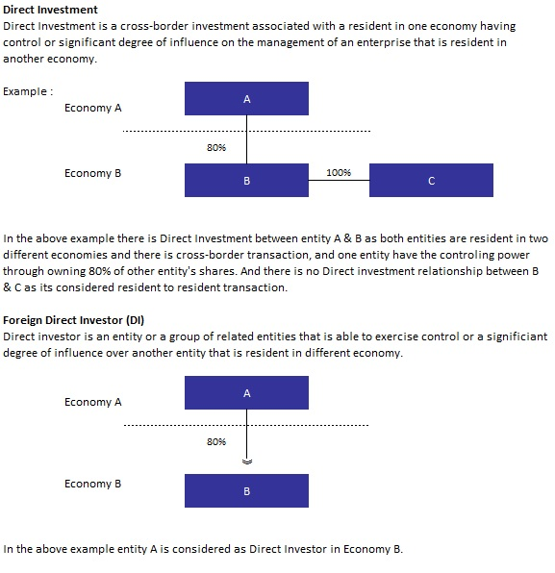
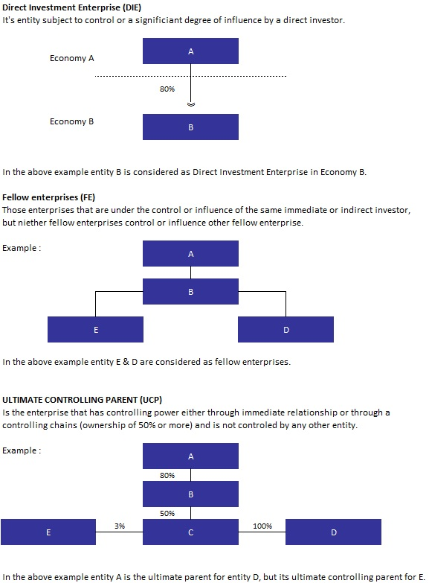

Portfolio Investments:
Portfolio Investments are defined as investments in tradable debt or equity securities between the entities that are resident in one economy and another entity that is resident in different economy.
Other Foreign Investments:
These investments reflect the foreign investments except for the portfolio investment or the foreign direct investment.
Main Economic Activity:
Main activity is the activity which contributes the most to the value added of the entity, it account for 50% or more of the achieved value added.
Resident in UAE:
UAE resident is any individual, establishment or other organization domiciled in the UAE or intending to stay for a minimum period of 1 year. Entities which are domiciled in UAE even if such entities are owned by foreign entities or nationalities are also considered as resident entities based on the principle of residence regardless of the nationality of their owners.
Non-resident:
A non-resident is any individual, establishment, or other organization that is resident outside UAE and or is intending to stay for a minimum period of 1 year. Entities that are located abroad even if they are owned by local entities are also classified as non-resident entities based on the principle of residence regardless of the nationality of their owners.

